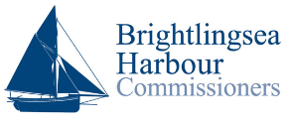

Brightlingsea Harbour
Designated Person Port Marine Safety Code Audit
December 2022

Brightlingsea Harbour Office
4 Copperas Road
Brightlingsea
Colchester
Essex
CO7 OAP
www.brightlingseaharbour.org

Audit completed by: Captain Jack Irwin
Email: cofc@brightlingseaharbour.org
Phone: 01206 302200
Port Marine Safety Code
The Port Marine Safety Code (“the Code”) sets out a national standard for every aspect of port marine safety. Its aim is to enhance safety for everyone who uses or works in the UK port marine environment. It is endorsed by the UK Government, the devolved administrations and representatives from across the maritime sector and, while the Code is not mandatory, these bodies have a strong expectation that all harbour authorities will comply. The Code is intended to be flexible enough that any size or type of harbour or marine facility will be able to apply its principles in a way that is appropriate and proportionate to local requirements.

References
- Port Marine Safety Code- November 2016
- A Guide to Good Practice on Port Marine Operations Prepared in conjunction with the Port Marine Safety Code 2016- February 2018
- Brightlingsea Harbour Marine Safety Management System (MSMS)
- Brightlingsea Harbour Byelaws 1990
- The Harbours, Docks and Piers Clauses Act 1847
- Brightlingsea Harbour Order 1927 as amended
- Brightlingsea Harbour revision orders 1972,1981,1985, 2002

Role as Designated Person (DP)
To provide independent assurance directly to the duty holder that the MSMS, for which the duty holder is responsible, is working effectively. Their main responsibility is to determine, through assessment and audit, the effectiveness of the MSMS in ensuring compliance with the Code.

The Harbour
Brightlingsea Harbour is a small mixed leisure and commercial port with a rich heritage, situated in Brightlingsea Creek close to the mouth of the Colne Estuary where it meets the Blackwater and Thames Estuaries. The Harbour is within a nature conservation area of international importance. The River Colne is navigable on the tide for 7 miles to Colchester in Essex and the River Blackwater is navigable for 11 miles to Maldon. Brightlingsea is a day sail from most ports on the Thames Estuary.

Harbour Management
Brightlingsea Harbour is a Trust Port managed by Brightlingsea Harbour Commissioners. There are eight commissioners which includes the Harbour Master leads a dedicated team of permanent and seasonal staff who oversee the day to day activities within the Harbour.
Duty Holder Commissioners, Chairman- Andrew Scott
Harbour Master / Chief Executive James Thomas
Deputy Harbour Master Owen Evans
Audit
The audit process commenced at 1300 on 5th December through to 1530 on 6th December 2022. During this time, I had the chance to view the Harbour office, Marine Safety Management System and have a harbour launch tour of the harbour limits. I also had the opportunity to speak with the Harbour Master, Deputy Harbour Master, Chairman of the Commissioners, Apprentice and newly appointed Head of Maintenance.
All personnel were very pleasant and most importantly knowledgeable of their role, the MSMS and appeared to have genuine vested interest in their job and the Harbour as a whole.
In the course of the audit, using the recommended PMSC ‘Aide-memoire’ For attending MCA Officers & Harbour Authorities, I was presented with evidence by BHC. With the exception of those observations and recommendations listed below.
I believe the other areas referred to in ‘Aide-memoire’ For attending MCA Officers & Harbour Authorities were found to be satisfactory.

Audit Findings / Recommendations

Finding | Recommendation | Responsible | Completed
SMS update / review date not immediately obvious | Suggest adding a page detailing what amendments have been added since the last review.  Example in Annex A | HM / DHM
Emergency Details sheet proforma | Suggest compiling a pro forma to ease use by any should an emergency occur  Example in Annex B | HM / DHM
‘Lone Working’ section of SMS information in several sections. | Compile all information for Lone Working- Procedure, risk assessment and equipment to take in one section | HM/ DHM
Information pertinent to employees available online and in the employee’s handbook | Suggest a formal / informal weekly briefing to all employees at the beginning of the week for example. To update all on operations, weather safety etc  Example in Annex C | HM / DHM
Lifebuoy in marina found to have a small crack and be UV faded | Change out lifebuoy for new. Suggest inspection routine to be included in the Planned Maintenance System | HM / DHM | 08/12/2022
Lifebuoy life line on Town Quay found to UV faded | Change out lifeline for new. Suggest inspection routine to be included in the Planned Maintenance System. | HM / DHM | 08/12/2022
Fire Extinguisher Box signage faded | Signage to be replaced | HM / DHM | 14/12/2022

Other Areas covered during the audit

Lengthy discussion with the newly appointed Head of Maintenance. Although Ross has not yet taken up the role (beginning in January 2023) it is good to see that he has a well thought plan and has some good ideas to modernise and streamline the department. I look forward to seeing the progress in the maintenance department on my next visit.

Discussion with new Head of Maintenance:
Items discussed:
- Grab bags to take when going to specific harbour craft
- Workshop flooring to improve working environment
- Bar code stock control
- Storage
- Planned maintenance system
- Manuals
- Booking System
- Training courses
- Cleanliness
- Manual handling training
- Inventory
- Fuel consumption records
- Defects

Annex A
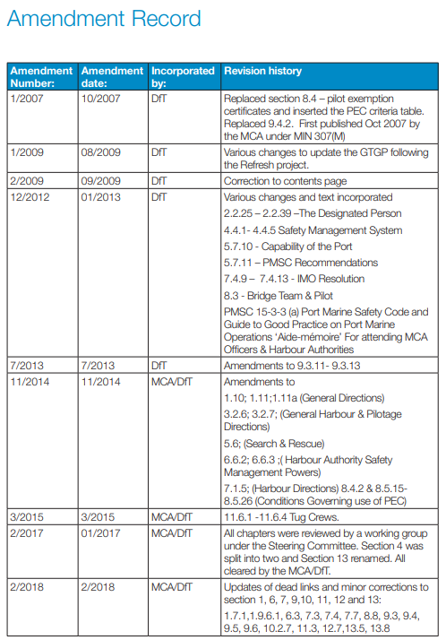
Source:
A Guide to Good Practice on Port Marine Operations, Department for Transport, February 2018

Annex B

Example emergency reporting form. This is from a vessel’s perspective can be adjusted to work form a shore perspective. To aid with any member of staff raising the alarm in the event of an emergency / situation requiring outside assistance to ensure all as much information as possible is relayed to the necessary authorities.

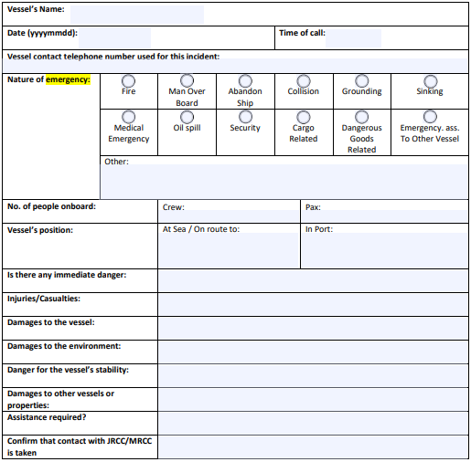

Annex C

I understand that there is a small workforce at the harbour and they work closely with each other day in day out. On the ship I work on we have recently introduced a weekly toolbox talk session with each department to ensure everyone is aware of any issues that may affect their day to day work and also lets them bring up any points they may feel are relevant.

Weekly Staff Briefing
- Weather forecast for the coming week
- Activities taking place
- Defects
- Accidents / Incidents
- PPE
- AOB

