Brightlingsea Harbour Commissioners
Stakeholders Meeting
1830hrs Colne Yacht Club 02 May 2023
Chairman A Scott
Harbour Master J Thomas
4 x Commissioners D Nicholson, F Brown
52 x Stakeholders

Chairman welcomed those in attendance.
Environmental Update
HM explained;
Scrubbing Impact – Essex University sponsored project
Crabbing – Jane Stewart, eco crabbing.
Restoration Project, Blue Marine Foundation – Oysters.
Anti fouling effectiveness – University sponsored project

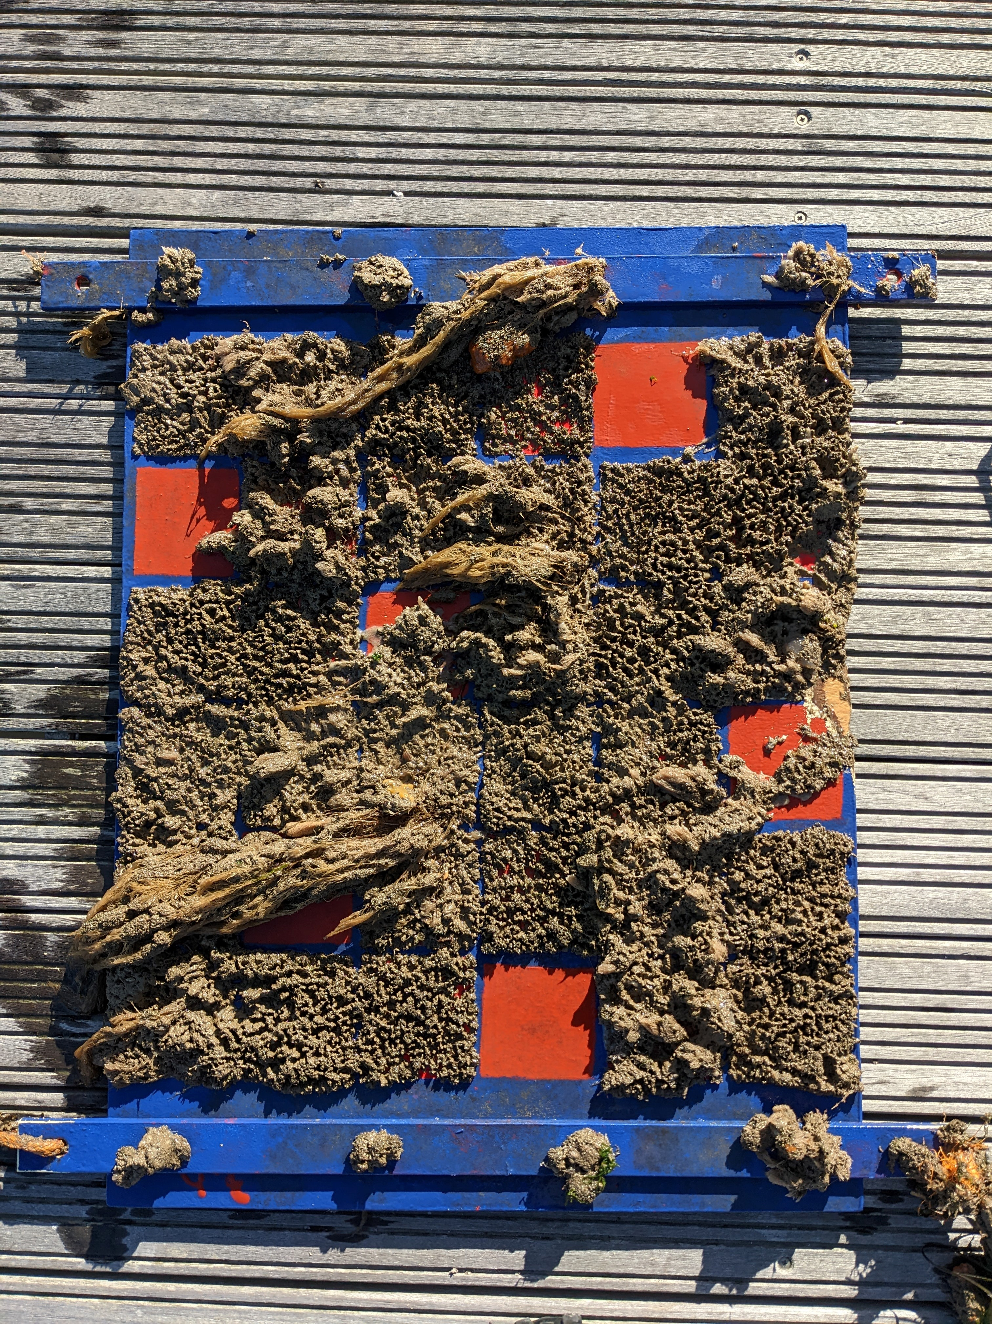
Essex University have been evaluating different anti-foulings, using plates suspended from harbour pontoons. The three clear patches on the plate are, according to the University team, referred to as elastomer.
The University’s scientists have provided the statement below, we hope, in the future, to receive a simpler definitive response.
“The work was to look at molecular analyses of the microbial communities on the different coatings, so not looking directly at effectiveness.

Take-home message from recent inspection is that the elastomeric fouling-release coatings performed the best by far (over this time-frame, under those conditions etc. etc.).
The toxic coatings provided little or no protection against the tube-building shrimp that you can see covering most of the test-patches on the image. The clear patches are the elastomers.

Although soft, the mud tubes of skeleton shrimp are not actually that easy to remove. Barnacles were not a major problem, but that is probably mainly due to competition for space on the toxic coatings and their inability to stick to the silicone elastomers in moderate flow.

This actually complements the work that a colleague has been doing on paint flakes in the sediment. Although this is all very preliminary, if it turns out that silicone elastomers are the best choice for here then this would automatically reduce the input of paint into the sediment (because they do not require scrubbing) and any paint that does make it into the environment would not contain any active biocides.”

HM’s interpretation is.
The three red patches, clear of fouling, featured in the picture were of the elastomer, I believe such a brand is https://www.hempelyacht.com/en-gb/products/biocide-free/silic-one/case-1

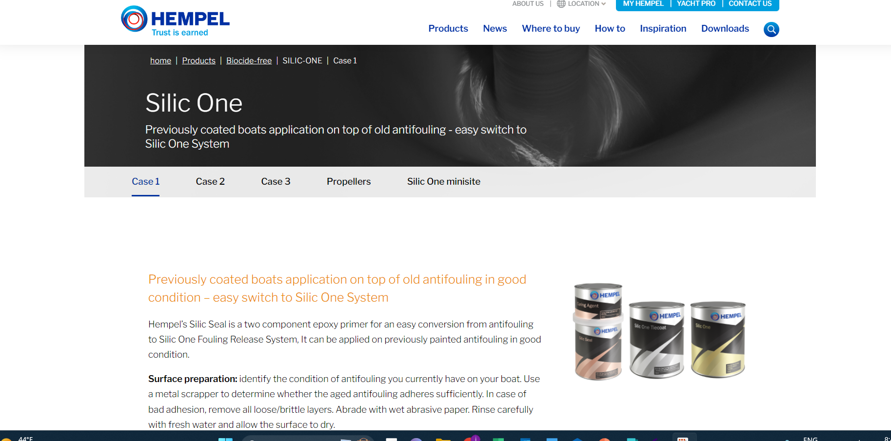

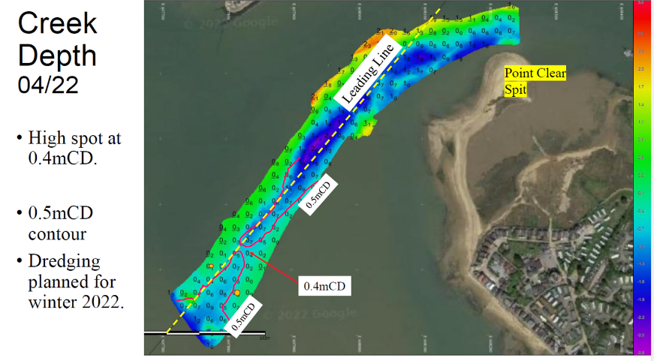
Duncan Nicholson Harbour Commissioner presented ‘Dredging Surveys’.
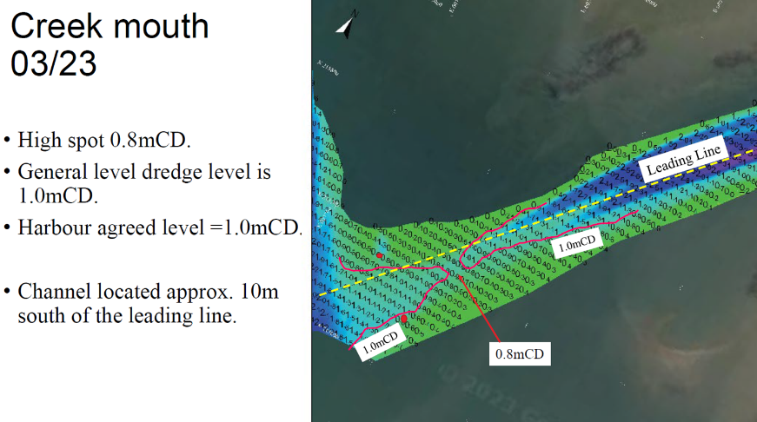

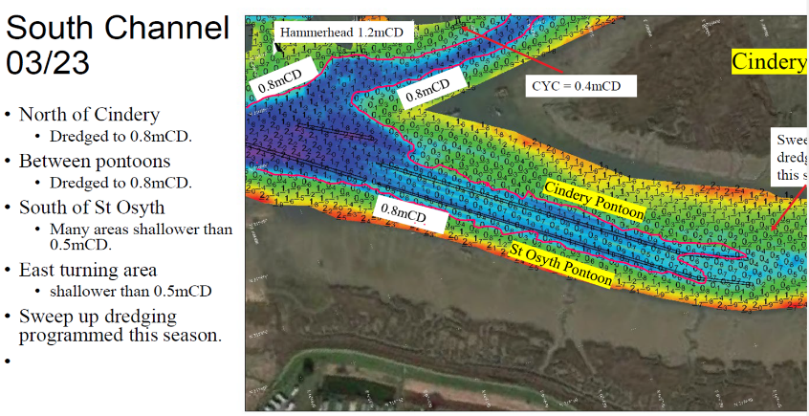
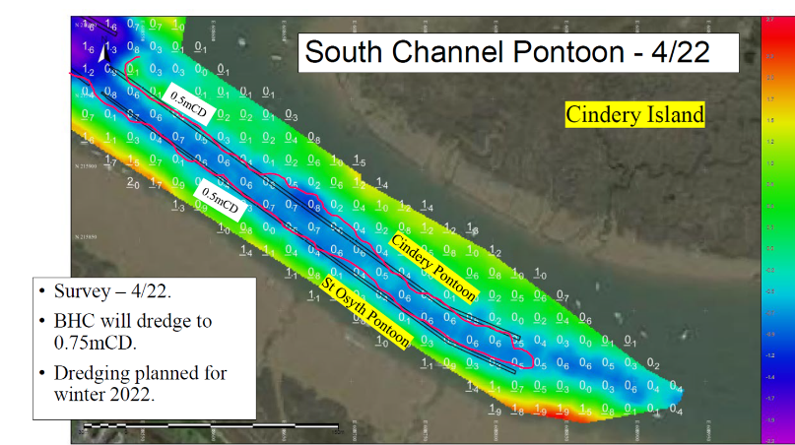

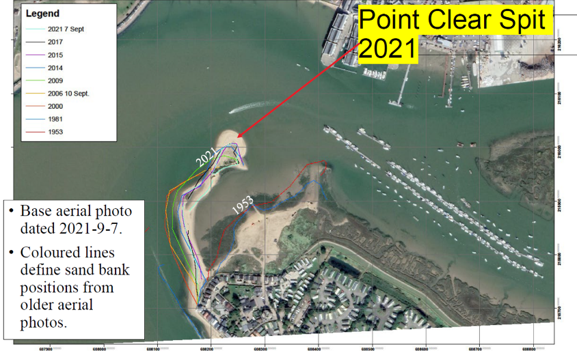
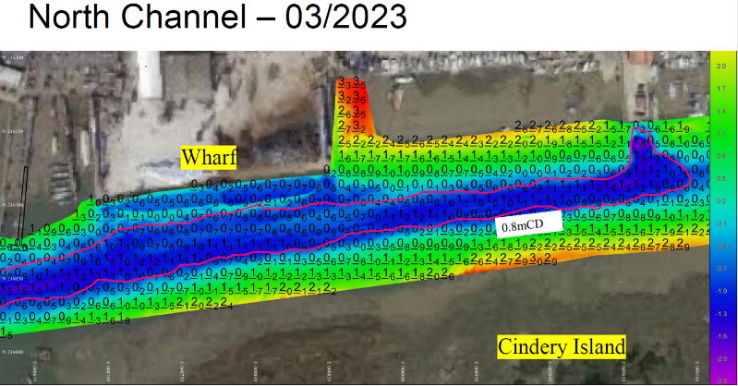

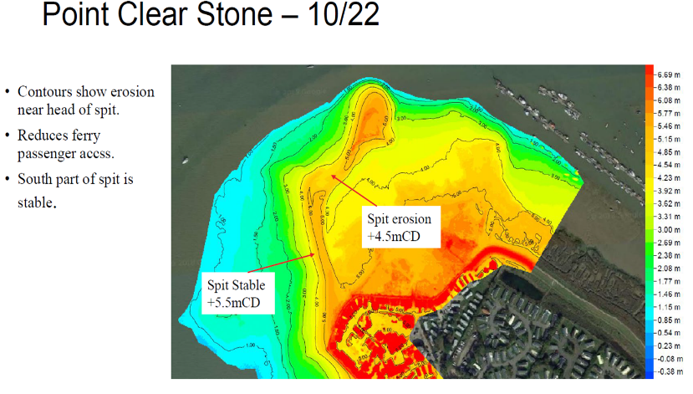
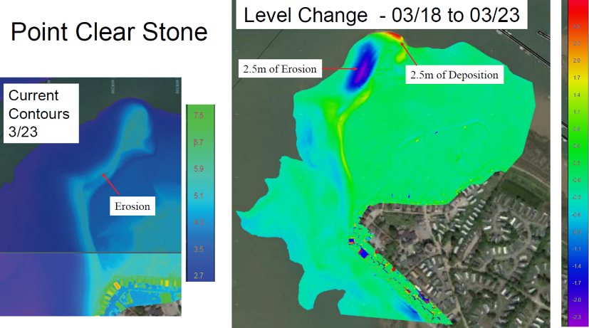

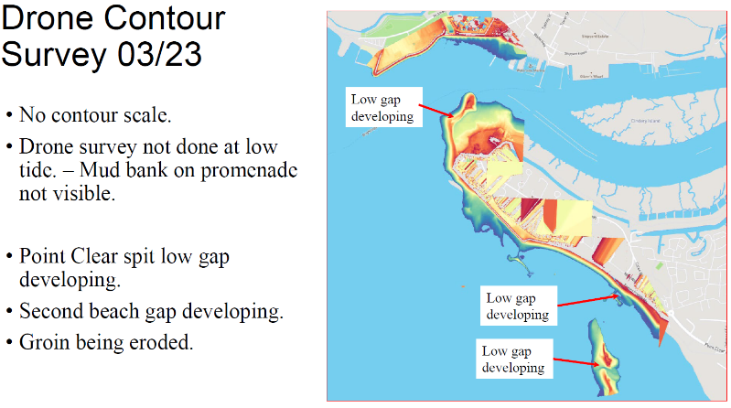
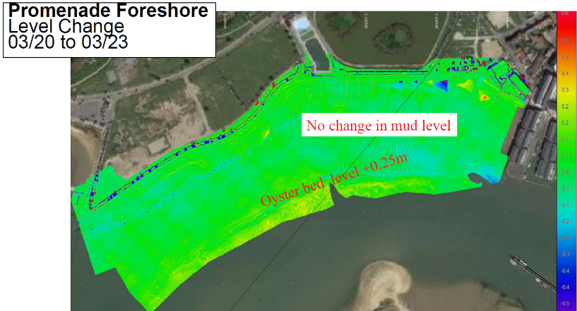

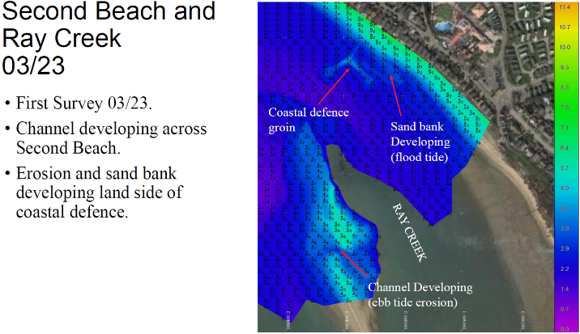

Conclusions to Surveys
- Dredging near Creek Mouth is meeting BHC’s objective of 1m below CD level.
  - The deepest channel is approx. 10m south of the Leading Line.
  - There is an area, close to Creek Mouth where the depth is around 0.8m below CD. The HM intends further dredging in this area in the next few months.
- South Channel Dredging -for the Cindery and St Osyth Pontoons is achieving the 0.75m below CD objective.
- North channel 0.75m below CD achieved.
- Point Clear Spit is being monitored.
  - The head of the spit is moving east.
  - The spit provides protection to the Council Pontoon and Marina.
- Depths on the promenade foreshore at BSC ramp have not changed over the last 3 years.
- Second beach surveys show erosion. Monitoring will continue.

Q1. Is there Bathymetry for further up the Creek. A. Yes although not included in the presentation.
Q2. What do you believe will happen? A. Don’t yet know. BHC are gathering, this is baseline data to help us understand.
Port Marine safety code

Accidents
- Leg Injury on Fishermans pontoon due to slip. – Minor Injury
- "Sonya" hit marina sill on leaving this morning - 0630. Two persons onboard, one man fell through hatch below decks and injured head. RNLI, Coastguard and Paramedics attended. Casualty taken to hospital. Vessel berthed safely back alongside in marina. – Damage, Head Injury.
- Allision Ferry with Hammerhead – Damage, No Injury. (An allision is when a vessel hits a structure, while a collision is when two vessels hit).
- Allision Vessel has crashed into the life ring holder on E pontoon in the marina, causing serious damage. Happened between 24/3/23 - 27/3/23. No visible damage to surrounding boats. – Damage, No Known Injury.
Incidents
- Yacht taking on Rainwater pumped out and will contact owner and assess in 24hrs. – Damage unknown, No Injury.
- Navigation buoy near fuel pontoon light bracket was bent we have bent it back into place. – Damage, no known injury.
- Vessel aground at St.Osyth creek Staff took crew ashore. Stated coming back tomorrow to retrieve – No Reported Damage, No injury. (Still aground on Howlands)
- Yacht (Cindery South) discovered sinking bow first during morning rounds 8am. Immediate action taken, owners, contacted and Contractors responsible bailed out, towed the vessel into the marina for Immediate repairs. Damage unknown, No Injury.
- Vessel discovered submerged was later bailed out when tide was low enough and assessed for damage with on-board bilge pump not working. Damage unknown, No Injury.
- Cleat ripped out by Vessel under load. Damage to Vessel, No injury.

Security
HM spoke on the following,
- Police Prosecutions
- NCA Prosecutions
- Port security is overseen by Govt and Port Facility Security Officer, they manage the Port Facility Security Plan, we comply with the Plan and work with the port.
- The spring theft spate has not yet happened, make it tough for them don’t leave out easy pickings. Despite being able to see thieves on CCTV, a prosecution is less than certain.

- 3 x PWC Prosecutions for breaching CBC / BHC bylaws have now been completed. Covid-19 impact has slowed down the justice process. One from the end of 2021, the other two from 2022
- Co**** – did not attend the hearing
- £400 fine
- £40 victim surcharge
- £150 costs

- Jo***** – pleaded guilty
- £350 fine
- £140 victim surcharge
- £150 costs

- Bu**** – pleaded guilty
- £200 fine
- £20 victim surcharge
- £150 costs
- BHC will Educate with Leaflets, locating simple speed Buoys, producing an even simpler map.
- CBC have not yet committed to funding River Patrol this year.
- BHC are in discussion with Orchards, St Osyth Parish Council, and Tower Estate to control access to water from St Osyth this year. BHC do not have any authority on that land.
- The Police are very thinly spread and cover other areas.
- Unfortunately, the Latest government legislation has done little to help the current problem, registration is voluntary. The reason why they launch at Point Clear is to avoid registration. Anonymity is the issue. One benefit with the legislation, it will make prosecutions easier once a serious incident or accident has occurred.
- Studying best Practice and working with other Harbours, advisory groups, legal, Landowners and councils.
- Work continues.

Other issues
- PMSC Inspection and report by the Designated Person has been produced and is published on Website.
- New Pilot boat has been inspected is MCA coded, compliant and is in service.
- Discussions with Harbour Clubs leading to internal code of practice generation.
- Swimmers and Paddleboarders.
Q. Did the DP meet stakeholders. A. He was entitled to talk to anyone and encouraged to do so, however there was no specifically engineered meeting. BHC would ensure that on the next visit a meeting of such would happen.

Harbour Development Plans

STAKEHOLDERS who are they?
Port Users.
Brightlingsea community of approximately 10000 people,
Local businesses,
Port employees,
Interest groups.
Councils; Town, District and County.
The National economy.
The interests of all Stakeholders are recognised by the Commissioners and guide their decisions.

CAPITAL SPENDING
Equipment- Plan until 2050 £1,362,819.50
Replaced pilot workboat – Colne Leader.
Wreck house and Workshop improvements.
Pontoon Repairs Town Jetty.
Marina Dredging.
Maintenance Dredging Harbour.
Website, booking platforms/IT/ App
Second Charter Boat – Electric
We must put aside at least £63000 to reserves annually to allow BHC to replace equipment and facilities as they wear out in the future.

Maintenance Dredging
Main Channel
• The deepest part is approx 10m west of leading line with depths better than 1m below CD all way down, except of a patch at around 0.8m below CD. We aim to correct this over the year.
• The Town pontoon to Oliver's Wharf and Fuel Barge, maintaining a depth of 0.75m below CD, we continued to achieve and will run down again this year.
• Area of the Fuel Barge, maintaining a depth of 0.75m below CD, once again achieved.
Leisure Harbour
• The pontoons and some moorings in the South channel dredged to a depth of 0.75m below CD.
Leisure Marina
• The Marina Depth, mud will always be kept in suspension.

ACTIVITIES
The harbour is a commercial business and must be run as such. The revenue generated is used to provide support to stakeholders, berth holders will derive the benefits as will all stakeholders, there are no preferential stakeholders.

Wharf and commercial activity 13 x ships since Nov, supply issues have resulted in reduced numbers of ships on the wharf in last 6 months.
Community Commitment Regatta Fireworks, Carnival
Local Businesses Lobster Hatchery, Engineering firms, Electrical provision, Dredging, Security CCTV and access, Cleaning, Marine service providers, Chandlers, Clubs.
Schools Engagement Schools week, still very much engaged. There was speculation that the Harbour had withdrawn from funding schools week, this is not true. Last years accounts £5913 was spent on schools week that does not include staff and vessel costs. The previous year cancelled due to Covid so we didn’t spend anything on it. We operate in partnership with Pioneer Trust, who approach the schools. The programme is full this year with schools volunteering to take part. If any school chooses not to take part that is a matter for them.
Q. Why is the local school not taking part, they say it’s because it’s too expensive. A. HM stated it’s not possible for him to discuss the negotiations with the school as they were confidential. All the schools are stakeholders and as stated earlier there are no preferential stakeholders. It’s a shame they chose not to take part but that was not something that the Harbour could do anything about. BHC have continued to provide significant financial support to Schools Week. The Pioneer Trust arrange the week and are the contact point for schools.
Charitable Causes RNLI, Brightlingsea in Bloom, 1 st Responders, Regatta, CYC Fireworks, Christmas tree festival, St Helena’s hospice, Walking with the wounded and the seafarers charity.
Apprenticeships Boatyard and Marina apprentice passed. He will complete the summer season at BHC and gain the advanced Power Boat commercial certificate before moving on in October.
Workboat crewmember apprenticeship mid-term on track.
Second Workboat crewmember apprenticeship Starts September.
Business and administration Apprentice now in place.
Colne Navigation Trinity House have carried out their annual, independent, inspection of the aids to navigation for which BHC are responsible. Trinity House found they were all in good order and subject to regular servicing.
Pilotage and vessel support
Leisure Moorings Pontoons full, some fore and aft remain.
Marina Superfast Wi-Fi 274Mb is now available. Introduction of Key fob for Showers and Toilets in next few weeks.
Taxi Popular still, cash price £1.50 frozen and Children still free.
Visitors numbers. Annual 22/23 3107 21/22 3174
Charter Up and running for the season
Black Buoy Hoping to restarted the popular trip for lunch at the Black Buoy in Wivenhoe, now that a chef is in place.
Ferry Around 17,000 Passengers carried last year. 20203 will be the 20 yr anniversary.
Staff Training Gene
Oil Spill response Exercises carried out. The exercise was validated by the Maritime and Coast Guard Agency.
Trg Permanent Cadre : x 12;
1 x Day Skipper Theory
4 x First Aid
2 x Level 2 RYA
2 x VHF Radio Certificates
1 x Fire fighting
1 x Sea Survival
2 x Apprentices training
2 x Equality, Diversity and Inclusivity
2 x Pilot boat Crew

Trg Non-Permanent Cadre : x 16;
2 x Advanced Powerboat preparation
Pilot Boat Operations
1 x Level 2 RYA
1 x VHF Radio Certificates
1 x Pilot Operations
Induction Training
Provision of such to three employees.

Internal Role Training
Refresher Training for incremental staff.
Developmental training for staff generally, happens which include specialist trg but also, IT, Software, media training.

Provision of Fuel
It appears (May 2023) that BHC now provide some of the least expensive diesel fuel in the area;

Commercial 60/40
BHC 1.066 Inc VAT 1.481 Inc VAT
Bradwell 1.35 +VAT 1.68 +VAT
Poole (for comparison) 1.64 Inc VAT
Woolverstone 1.70 Inc VAT
Chatham 1.69 Inc VAT
Titchmarsh 1.63 Inc VAT

This Year

1.Town Jetty. BHC and BTC are discussing options for the Town jetty and BTC boat park.
2.To Launch, run and maintain an electric boat.
3.To continue to ensure that BHC investigates emerging technology and where benefits are identified it considers adding them to their inventory as equipment is replaced.
4.Following the evidence gathered from anti fouling project in the last 12 months, BHC agreed that further consideration should be given to the environmental impact of current use and ways to mitigate this. We are now taking part in an university research programme on anti-fouling.

Issues not covered in Presentation.
Questions from Stakeholders
- What is the space allowed between each mooring on Pontoons?
- Minimum Six Foot.
Q. Why can’t I put any one of my boats at anytime in my berth?
- Berth usage, it is an accepted marine practice nationally that one berth is for one boat. If you wish to change the boat then you must formally change it.
Q. Can the Harbour mark Pincushion Island with Withies?
- Done.
- Can the Harbour move the spare Jetty section when not working on it so I can sail my dinghy up the Hard?
A. Yes, will be done in the next 2 weeks, for a period.

Meeting Closed 2010hrs

