Brightlingsea Harbour Commissioners
Stakeholders Meeting
1830hrs Brightlingsea Sailing Club 21 Nov 2023
Chairman A Scott
Harbour Master J Thomas
4 x Commissioners P Foley-Brickley, F Brown, C Watkins, D Stoker
27 x Stakeholders

Chairman welcomed those in attendance.
He explained BHC is a Statutory Harbour Authority
Established by Act of Parliament in 1927 as a ‘Trust Port’, an Independent Statutory Body, overseen by the Secretary of State for Transport
Trust Ports are “a valuable asset presently safeguarded by the existing board whose duty it is to hand it on in the same or better condition to succeeding generations. This remains the ultimate responsibility of the board and future generations remain the ultimate stakeholder”.
They are required to operate on a commercial basis.
Surpluses are reinvested in the Harbour for benefit of stakeholders.
All Commissioners, other than the Harbour Master, are unpaid volunteers.
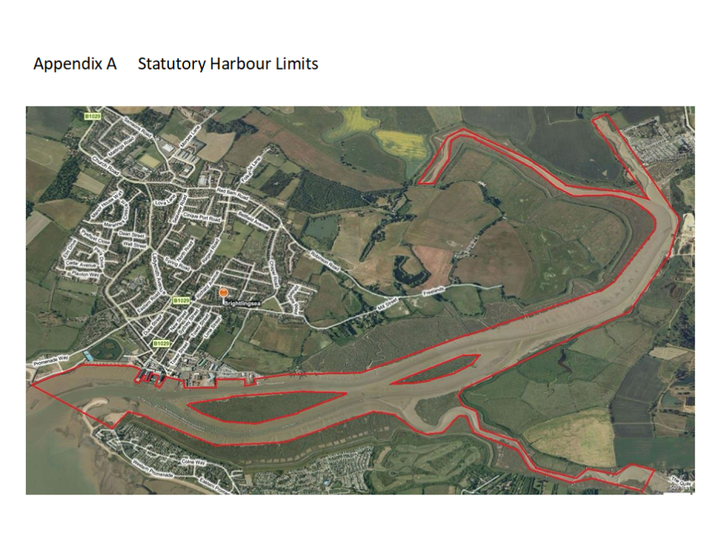
He described the Harbour Limits

He then explained that in addition, following the closure of Colchester Harbour in 2001 BHC became
The Local Lighthouse Authority for the River Colne.
Responsible for specific buoys with the River

The Pilotage Authority for the River Colne and Brightlingsea Harbour.
Colchester City Council remain responsible for the management of the River Colne.
CCC make and enforce bylaws
BHC can provide assistance as agents of CCC (e.g. River Patrol)

The role of the Commissioners was also covered, they are;
The Duty Holder for safety
To set BHC’s strategic aims,
Ensure that the necessary financial and human resources are in place to meet those objectives,
Review management performance in meeting those aims.
To challenge constructively and help develop proposals.
To scrutinise the performance of management in meeting agreed goals and objectives and monitor the reporting of performance.
The Chief Executive / Harbour Master has executive responsibility for running the business and is a Commissioner.

Financial Year ending 31st March 2023

Turnover £766,973
Surplus £41,202
slightly under 5.4% of turnover.
That surplus is reinvested for benefit of stakeholders
Mainly in replacing assets which have reached the end of their life
E.g. piles, pontoons, boats, etc.
BHC has around £1.36m invested in those assets
HM calculates that BHC need to put aside each year, on average, £ 50,000 to £60,000 so that we can replace those assets as required.
Expect harbour fees to increase in line with CPI.
This has been the approach for several years.
Though 2023/24 fee increase was less than CPI.

Main sources of income

Colchester City Council
Fee to BHC for taking on the local lighthouse authority and pilotage responsibilities
Following the closure of Colchester Port
Pays for buoy maintenance, work / pilot boat depreciation,
Fees from commercial shipping
Pays pilot fees, work /pilot boat depreciation, work / pilot boat crew, associated harbour costs, etc
Harbour dues
Low compared to other harbours.
Maintenance of harbour navigation aids, removing hazards, harbour monitoring and information, staff, etc.
Berthing fees
From BHC owned moorings
Some of lowest on the east coast
6,000 to 9,000 boating visitor nights
Ferry, Tours and Water Taxi
Makes a small surplus
Ferry and Tours enables around 18,000 people to see the harbour and Colne from a boat
Grants

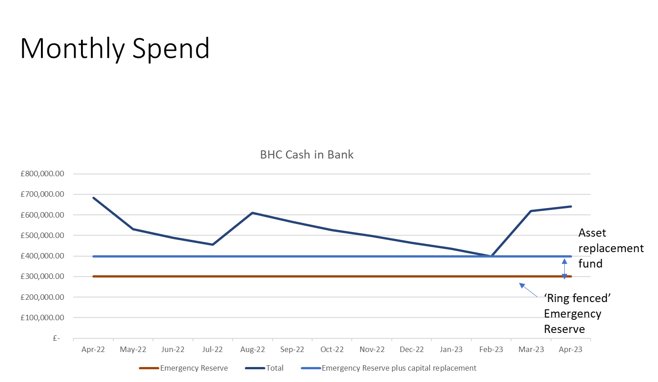

Cash in Bank

April bank account contains all the mooring fees paid in February and March. Total about £690,000

The cash then steadily drops as BHC uses that income throughout the season.

In July Colchester paid their fee.

Lowest point is February, when the cash is just under £400,000.

Then the bank cash increases as mooring fees for next season are paid.

BHC holds a £300,000 reserve, to enable continued operation if there is a severe interruption.

We currently have around £100,000 in cash put aside to replace assets as they wear out.

Strategic Objectives

BHC strategic objectives shown on the website and in the annual report.
Last updated May 2021
Presented at the spring 2023 stakeholder meeting.
BHC believe it is time to review that strategy.
That will involve consultation with stakeholders.
Process is likely to take at least 1 year.
BHC publish a draft ‘straw-model’ document.
BHC will then consult on that document, seeking views from stakeholders.
BHC will then develop their revised strategy and consult again if appropriate.
The final strategy will be produced and published.

Port Marine Safety Code

Remediated boats – 4 at the moment, process.

Blue Marine Foundation – Oyster Education

Essex University is looking at Antifouling projects within the Creek.

Accidents
- Visitor yacht collided with resident's yacht . Damage to gel coat. Owners both informed and details provided. No injury.
- Staff member fell overboard when coming away from St Osyths pontoon all fine life jacket inflated. Leant over lost footing. No Injury
- Vessel caught electric meter on pontoon with fender, dislodging meter stand - no damage or marks on vessel, meter pedestal secured back to pontoon. No Injury
- Vessel Allided with town jetty breaking side planks , replaced Immediately. No Injury
- Vessel hit and damaged stationary vessel while attempting to come alongside hammerhead. Staff approached owner and pointed out the damage. No Injury
- Visitor yacht hit stationary Vessel on departure of marina. No Injury
- Vessel collided several times with other vessels and with 2 x meter stands causing them to collapse, arc cables and cease supply in West basin. No injury
- Visiting yacht caught fender Dock and tore it off. No injury
- Needle stick injury, whilst parking the vessel threw the mooring rope over a cleat, caught finger on a piece of frayed wire rope, first aid applied. Not reportable
- Banged head on under side of jetty. Not reportable
- Vessel chaffed its bow line which parted, on swinging mooring. It then collided with three vessels. All mooring holders have been notified. No injury
- Staff using battery drill to drill out a rounded screw. Drill bit jumped injuring hand, cleaned and bandaged. Not reportable

Incidents
- Security called indicating 4 jetskis had proceeded passed them and refused to comply. Tower security gathering as much evidence as safe to do so. DHM instructed BHC staff not to engage given the nature of those on the skis from Rowhedge.
- Fishing boat reported one ski had a young child with no life jacket on the back of one causing nuisance near his vessel.
- 3 jet skis launched from point clear (one stand up ski, two conventional) sped through harbour, up past morgans, proceeding to then increase speed further past morgans last pontoon 'playing about' by Underwoods Hard.
- Vessel launched by park and ride set off towards Morgans, estimated speed 25-30kts. The vessel returned towards the harbour, were met by police.
- Vessel speeding in the swimming buoys warned for speeding in the harbour area staff informed him that he needs to go outside on the harbour limits. Abusive to staff.
- RHIBs hung off vessel on Heritage pontoon, has caused cosmetic damage to vessel Black rubber marks.
- Vessel has taken in water and despite 2hrs pumping no success. Early tide 17/9 water drain from stern outflow only for vessel to refill on incoming tide . Vessel secured to FA . Have notified owner that vessel must be removed as an environment hazard.
- Vessel broke mooring floated onto Cindery island.
- Resident made inappropriate comments to female staff member on taxi, she asked them to cease. Other party involved apologised profusely explaining disease (Alzheimers). Staff member was satisfied with the outcome.
- Aggressive and abusive behaviour towards reception staff after repeated attempts to solve his problem with a TDC business rate demand.

Security

Police Prosecutions/ Investigations

Port security is overseen by Govt and Port Facility Security Officer, they manage the Port Facility Security Plan, we comply with the Plan and work with the port. Not publishing Shipping movement widely is part of that plan.

The theft spate has not yet happened, and it seemed it didn’t happen last year. It will only ever happen if attractive stuff is left out. Make it tough for them don’t leave out easy pickings. We may pick it up on CCTV, however prosecution is less than certain.

PWC Early season behaviour led to identifying and pursuing those involved. Some were involved in other activity. Daily Mail reported. Following that incident behaviour improved although the weather may have had some influence.

Harbour dues are paid by all users of the Harbour, failure to pay is an offence. Harbour, Dock and Piers Clauses Act 1847 sect 33 and Harbour Act 1964 Sect 26, refer.

There are a number of users who have avoided paying, this is mainly an issue of anonymity, the Commissioners are actively engaging with senior members of councils, police, owners to control access from Point Clear.

I have engaged with Stakeholders regularly and to date none have come up with a viable solution.

- Trinity House LLA inspection compliant and still well above our 97% requirement at 99.8%.
- New Pilot boat has been inspected again and is MCA coded, compliant and continues in service.
- We will do annual wash-up Clubs, Swimmers and Paddleboarders.
- Life buoys all remediated.
- Lone Worker system.
- Waste – Commercial oil, Commercial waste.
- Bins on Pontoons – Trial.

Storm Damage preparation was successful

DP inspection likely in January 24.

Complete winter service schedule on SOLAS, Lifejackets, Pilot Jackets, Life raft and other safety equipments.

Waste management audit by MCA successful and compliant.

Spot check of Pilot Boat compliance by MCA complete and compliant.

Security meeting with PFSO in compliance with the PFSP.
Harbour Development /Plans

STAKEHOLDERS
Harbour Users,
Anyone who thinks they are,
Brightlingsea and local areas community of approximately 10000 people,
Local businesses,
Port employees,
Interest groups.
Councils; Town, District and County.
The National economy.
Trust ports are independent statutory bodies run on a commercial basis by independent boards for the benefit of their stakeholders. Trust ports are accountable to those stakeholders. The interests of the wide community of stakeholders should at all times be the guide by which the board of a trust port sets the strategy and direction of the port.
Trust port boards should consult stakeholders on significant decisions, where appropriate. Trust ports can and should consult and engage with stakeholders in a variety of ways including through an open Annual Meeting.

CAPITAL SPENDING
Equipment- Plan until 2050 £1,362,819.50
Replaced Charter Boat – Electric.
Capital Equipment Replacement 2019
Strategy endorsed, with aim to replace, as and when necessary, with more environmentally friendly equipment.

Pontoon Repairs Town Jetty.
One section and timber frontage.

Maintenance Dredging Harbour.
Survey last week, Dredging throughout winter.

Website, booking platforms/IT/ App
Engines
Tide Gauge
We must transfer at least £63000 to reserves annually.

Maintenance Dredging
Main Channel
• The deepest part is approx 10m west of leading line with depths above 1m all way down, we will correct this over the year.
• The Town pontoon to Oliver's Wharf and Fuel Barge, maintaining a depth of 0.75m below CD, we continued to achieve and will run down again this year.
• Area of the Fuel Barge, maintaining a depth of 0.75m below CD, once again achieved.
Leisure Harbour
• The pontoons and some moorings in the South channel dredged to a depth of 0.75m below CD.
Leisure Marina
• The Marina Depth, mud will always be kept in suspension.

ACTIVITIES
The UK Government requires BHC to run the harbour on a commercial basis. BHC receives no government funding. BHC reinvest any financial surpluses to support the continuing and long-term success of the harbour for the benefit of its stakeholders. It is not stakeholders' money.

Stakeholder Benefits:

Community Commitment Regatta Fireworks, Carnival + Hard Fireworks.

Local Businesses Lobster Hatchery, Engineering firms, Electrical provision, Dredging, Security CCTV and access, Cleaning, Marine service providers, Chandlers, Clubs.

Schools Engagement Schools week, still very much engaged. We support and resource the Schools week in partnership with Pioneer Trust. They hold the activity licence, they engage with the schools and collect the contributions, the Harbour take no fees. We staff the event, provide transport, vessels and coxes, provide foul weather gear, lifejackets and management. This year in addition to labour and equipment we still contributed £1260. Feedback from schools was that this year was the best ever school's week.

Employment 11 Permanent staff Bsea, 2 local, 6 Casual Bsea, 4 local.

Charitable Causes RNLI, Brightlingsea in Bloom, 1st Responders, Regatta, CYC Fireworks, Christmas tree festival,
Museum.
Sea Change (Blue Mermaid) sailing Trust, Training of Apprentices.
Apprenticeships Josh moved straight into a role at Frank Halls.
Workboat crewmember apprenticeship on track.
Second Workboat crewmember apprenticeship started September.
Business and administration Apprentice on track.
Tourism Bringing visitors to town Boats/Ferry approx 24000.

Colne Navigation Trinity House: Independently inspected All in good order and subject to regular servicing.
Pilotage and vessel support
Leisure Moorings Pontoons full, some fore / aft remain and Swinging remain.
Marina Superfast Wi-Fi 274Mb.
Introduction of Key fob for Showers and Toilets.
Taxi Popular still, cash price £1.50 frozen. Dogs and Children still free.
No plans to add water taxi cost to berthing fees as some berth-holders don’t use the service.

Boats
Visitors Season 2019 2146
2021 2835
2022 2645 24% increase on 2019
2023 2490
Feedback from Visitors on survey when asked did you enjoy your stay in Brightlingsea harbour the answer was ‘Yes’.

Charters; Black Buoy Changes, There has been no enthusiasm from Brightlingsea Establishments. We would love to do Wivenhoe to Brightlingsea.

Ferry; Approximately 18,000 Trips this year. Survey indicates that majority visited Town.
Next year 20th Anniversary of ferry.

Wharf and commercial activity Continued activity 21 Ships since May in 5 months.
Cement and Scrap.
Windfarm Project support vessels continue to use the harbour.

River Patrols Continued resourcing of River Patrols and security, including Commissioners on board.

Jetty Management, maintenance and control of the Town Jetty. Currently no one pays for use of the Jetty. We provide staff, equipment, replacement of items.

Boat Park Management, maintenance and control of the Boat Park. BTC sets the price, not BHC.

Hard/Posts Management, maintenance and control of the posts, the cost of service is just above break even.

Staff Training General
Trg Permanent Cadre : x 13;
2 x OPRC 2P
2 x VHF Radio Certificates
1 x First Aid
1 x Fire fighting
1 x Sea Survival
1 X Coastal Skipper
1 x YM Theory
3 x Eq Div Inc
2 x Pilot boat Crew
1 x Adv Powerboat Trg
1 x LARS Trg
1 x Legislative Trg
1 x Social media Trg
3 x QB Trg
3 x Rolec Trg
3 x Access Trg
Trg Non-Permanent Cadre : x 12;
1 x Internal Crew Training

Induction Training
Provision of such to 2 employees.

Internal Role Training
Refresher Training for incremental staff.
Developmental training for staff generally, happens which include specialist trg but also, IT, Software, media training.

Provision of Fuel
It appears that we still provide some of the least expensive fuel 6p in every l goes to Pioneer Trust;

Commercial 60/40
BHC 1.12 Inc VAT 1.54 Inc VAT
Bradwell 1.21 Inc VAT 1.48 Inc VAT
Woolverstone 1.59 Inc VAT
Chatham 1.53 Inc VAT

Maintenance

Pontoons Pressure wash
Plank Replacement
Inspections

Piles Inspections
Blackening

Moorings Inspections
Chain and running gear replacement.

Vessels All in and remediated.

Nav Buoys All inspected and remediated.
Maintenance and repair ashore.

Jetty Replacement section.

Showers and Toilets Refresh.

Next Year

To Develop, run and maintain an electric boat, the Capital Equipment Replacement 2019 Strategy directed that equipment should be replaced, as and when necessary, with more environmentally friendly equipment. Currently used to run charters where formerly we used the Taxi.

Using proven electric boat technology

To continue investigating emerging technology and where benefits are identified, consider adding their use with BHC.

BHC agreed that further consideration should be given to the environmental impact of current anti-fouling use and ways to mitigate this.

We are now supporting an Essex University research programme on antifouling.

Issues not covered in Presentation
Questions from stakeholders
- The general feeling is that BHC are still more money orientated than customer /service care – please comment.

1a. We actively seek out feedback, customer surveys, have mystery shoppers which are satisfied, Google Reviews 522 - 4.5 out of 5, Trip advisor 57 reviews 4.5 out of 5, FaceBook Reviews 224 - 4.6 out of 5. Where a specific concern is aired, we act appropriately.

2. Is BHC able to accommodate larger yachts/ motorboats?

2a. Come and talk to us.

3. Please can you confirm… that the water testing results were poor from St Osyth Creek?
3a. BHC have not commissioned any water testing in the Creek, it is not a requirement of a port to conduct testing unless part of a project, BHC are not aware of testing by anyone other than the EA.

4. Bathymetry – thought not to include South channel , if not why not.

4a. It does.

5. Groins at the beach – understood to be TDC responsibility. Lack of maintenance – the group will make enquires with TDC unless BH have this in hand.

5a. You understand correctly, would advise to pursue through BTC.

6a. Could I join Powerboat waterski club and use speed above harbour limits- Colin Cooper says HM do not allow- HM says they can.

- Happy to discuss offline.

7a. Can the Webcam be improved.

- Yes

8a. What is wrong with the Tide Gauge.

- The tide gauge includes wind direction, speed and Tide height. One of the components has failed, so none of it works, we are waiting for a replacement in the meantime I will advise on website.

9a. Can the harbour publish the Commercial Harbour dues so the leisure users know they pay them.

- Yes.

10a. Can the Harbour dues wording be made clearer for PWC?
10. Yes.
11a. Will the harbour rescue a vessel in distress? In reference to the incident where a dinghy in Pyefleet capsized. The questioner asked if BHC would carry out a rescue in the harbour.
11. In case of emergency an immediate call should be made to the Coastguard via channel 16 or if you have no radio 999.
They will coordinate the rescue.
Following the call to the coastguard the reporter should advise BHC on VHF 68 or telephone.
BHC is not a rescue service, that said we would not standby and do nothing if deployed by the Coastguard or if presented with a situation where we could provide immediate assistance.

