DEPLOYMENT OF OYSTER SPAT FRAMES
BRIGHTLINGSEA CREEK AND RIVER COLNE, ESSEX

NOTICE TO MARINERS: 29TH June 2020 – 30TH June 2021

Exo Environmental Ltd. in partnership with Richard Haward’s Oysters, the University of Essex and Brightlingsea Harbour Commissioners, have scheduled to deploy Oyster Spat Frames (Figure 1) at two sites in the Brightlingsea Creek and River Colne, Essex for research purposes.

The two sites are marked by a yellow guard buoy (Pic Below). The coordinates of sites are provided in Table 1 in WGS84, and the chart locations are shown in Figure 2.

The Frames will be deployed for a period of up to 1 year, and all equipment will be removed at the end of the study.

Table 1:
SITE | LAT | LONG | Easting | Northing
1 | 51° 48′ 2.29″ | 1° 0′ 46.53″ | 609685 | 216206
https://maps.google.com?q=51.800635,1.012926
2 | 51° 48′17.87″ | 1° 2′ 19.12″ | 607820 | 215635
https://maps.google.com?q=51.804964,1.038646

Figure 1:
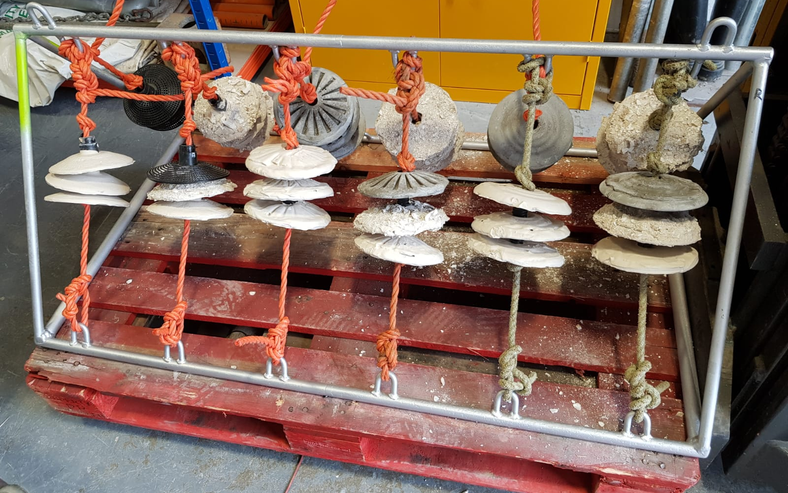
Figure 2: Flat Oyster Spat Collectors

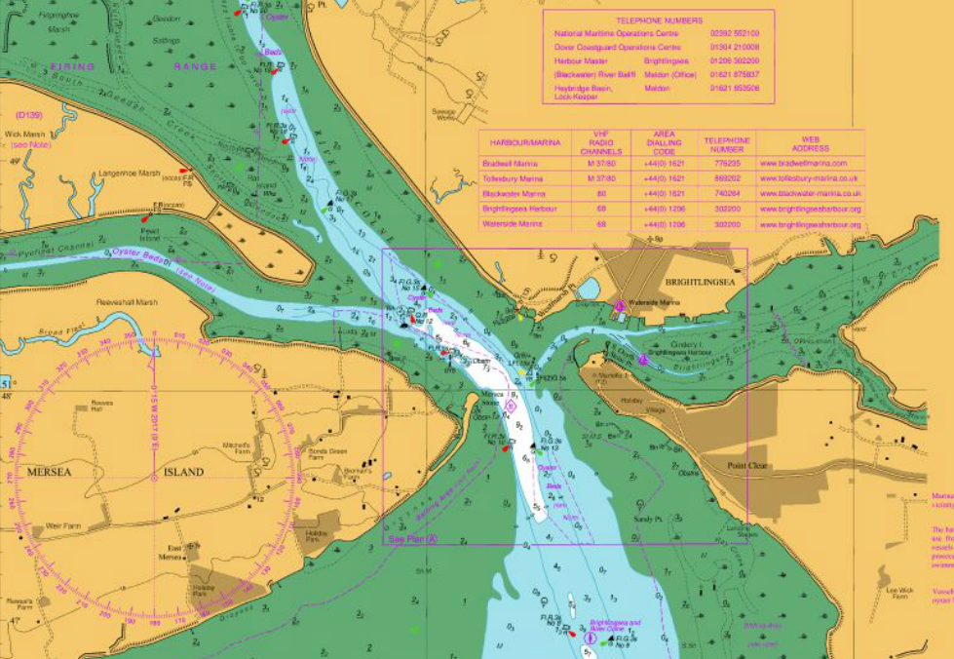

Figure 3:
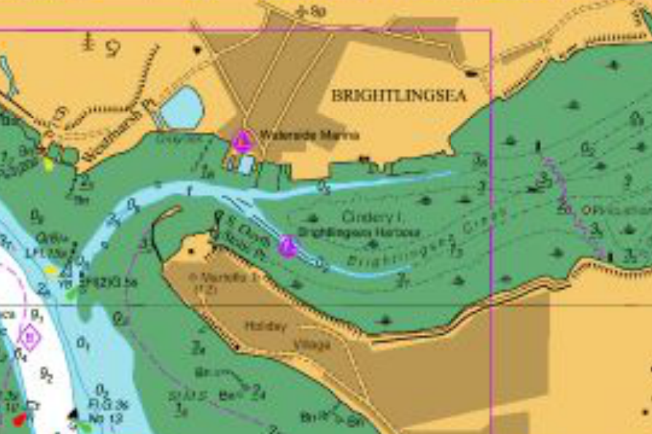

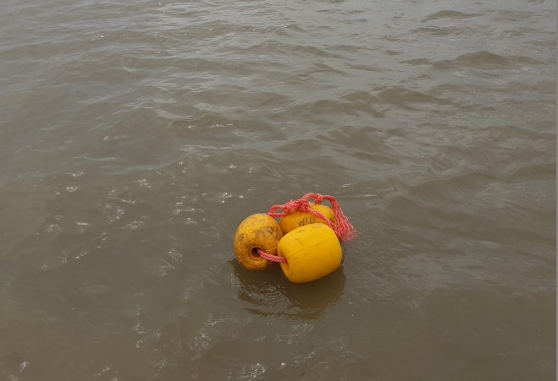
For further information please contact:
William Coulet – Exo Environmental Ltd. M: 0770 4831 754 E: william@exo-env.co.uk
Alternatively the Harbour Office

