ABPmer Notice to Mariners:
Survey Instrument – Seabed Deployment

Introduction
APEM Group Ltd has commissioned ABPmer to undertake a monitoring programme within the transitional and coastal (TraC) waters of the River Roach, River Blackwater and River Colne.

As part of this programme, ABPmer will be deploying CTD instruments (to observe temperature and conductivity/salinity) at five locations in these rivers for a 30-day period. The deployments are planned to take place on approximately 13-15 October 2026 and will be recovered approximately 30 days later.

During deployment/recovery operations, the vessel Jean T will be on respective locations for an approximate 1-hour period. When stationary other vessels are requested to pass at a safe speed and distance. VHF Channels 11 and 16 will be monitored throughout survey operations.

Mooring Details
The monitoring instruments will be secured within a seabed frame which will protrude above the seabed by 0.5 m in water depths ranging between 0m and 3.0m below Chart Datum. The frames will be secured to a 250kg sinker weight by weighted groundline. From the weighted groundline will be a riser chain to a surface marker buoy, a yellow special mark exhibiting light characteristics Y.Fl(5)20s.

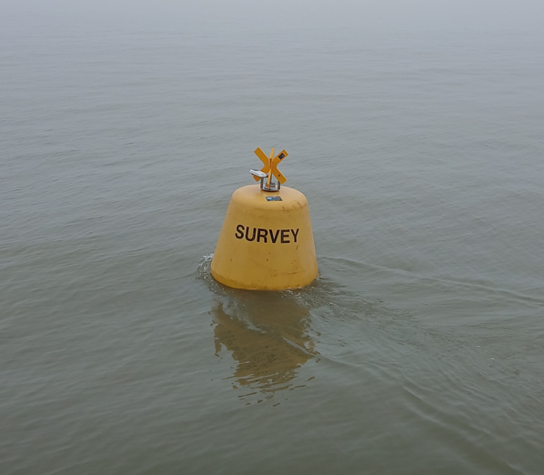
Figure 1. Surface marker buoy

Location Details
Table 1. Seabed deployment locations
Known Locations | ETRS89 |  | OSGB36 (OSTN15) |  | Water depth (mCD)
Known Locations | Latitude | Longitude | Easting | Northing | Water depth (mCD)
Colne - BCCTS1 - River | 51° 51.00880' N | 0° 58.00884' E | 604432 | 220999 | 0.5
Colne - BCCTS2 - Estuary | 51° 48.28371' N | 1° 0.21486' E | 607172 | 216053 | 3.0
Blackwater - BCCTS3 - River | 51° 43.36970' N | 0° 47.70971' E | 593155 | 206375 | 3.0
Blackwater - BCCTS4 - River | 51° 43.70214' N | 0° 43.94684' E | 588801 | 206827 | 0.0
Crouch/Roach - BCCTS7 - River | 51° 35.12602' N | 0° 47.99322' E | 594067 | 191111 | 3.0

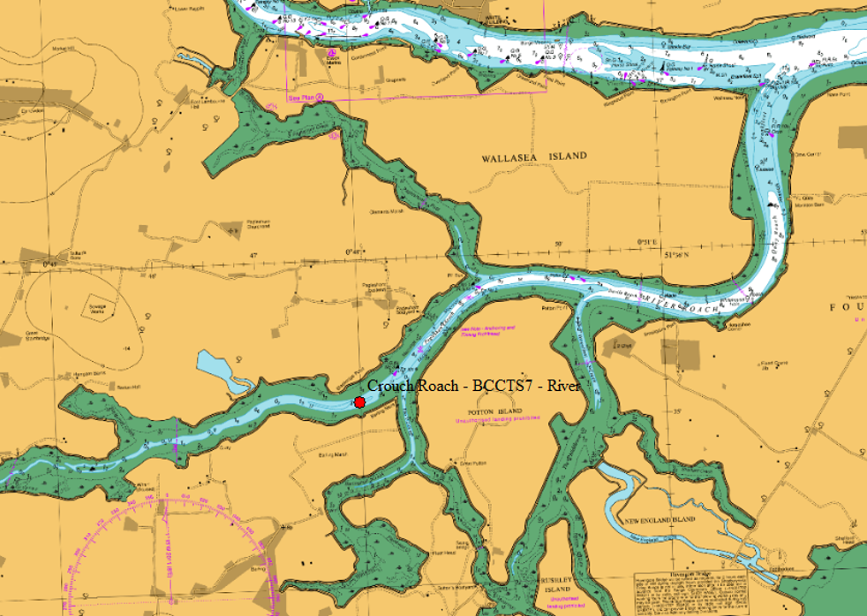
Figure 2. River Crouch/Roach location (1)

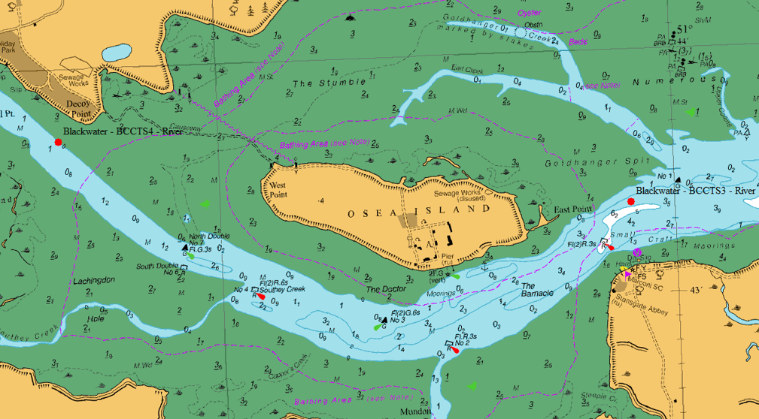
Figure 3. River Blackwater locations (2)

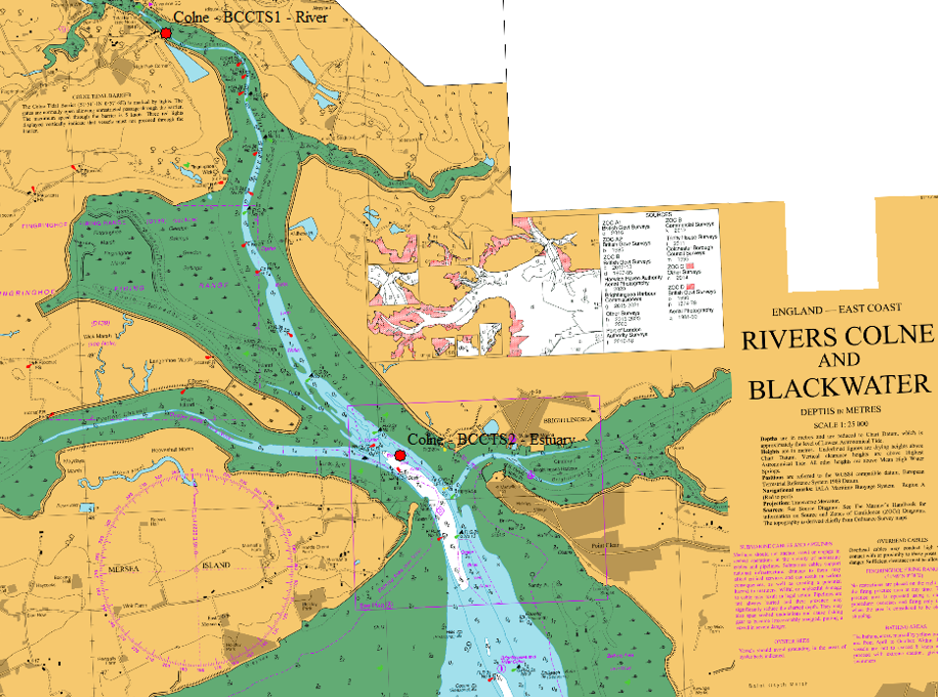
Figure 4. River Colne locations (2)

Survey Programme
The following table sets out the anticipated survey deployment programme, progress and weather permitting.

Table 2. Anticipated Deployment Programme
Date | Activity
13-15/10/2026 | Seabed frames and surface marker buoys deployed using vessel Jean T
- | Frames and surface marker buoys remains on location for deployment period. Buoy is yellow special marked with light characteristics Y.Fl(5)20s.
w/c 16/11/2026 | Seabed frames and surface marker buoys recovered using vessel Jean T

Vessel Details
Deployment/recovery operations will be undertaken from the Jean T. When stationary (during deployment/recovery) other vessels are requested to pass at a safe speed and distance. VHF Channels 16 and 11 will be monitored throughout survey operations.

Table 3. Vessel Details
Vessel | Description
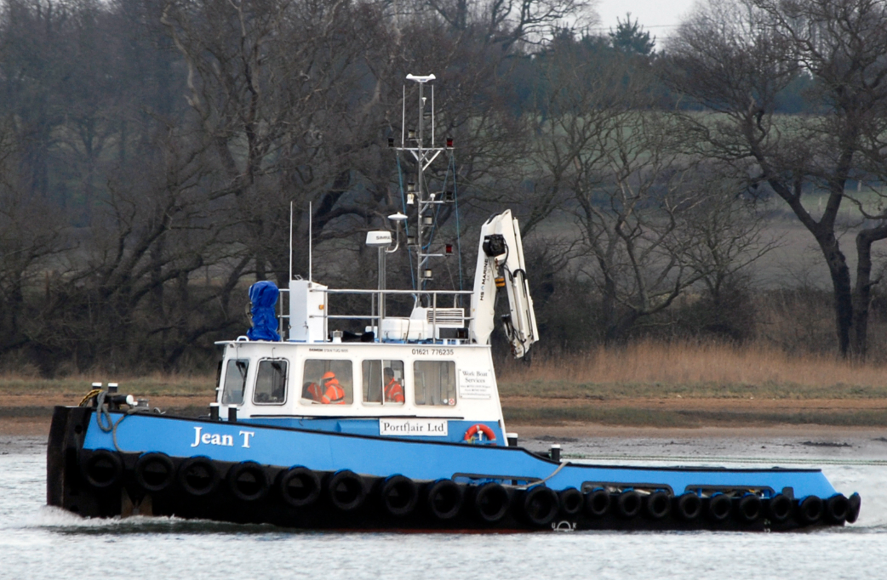 | Jean T  Owned and operated by Portflair Ltd  Bradwell-on-Sea  LOA: 16.9 m  Beam: 5.2 m  Call Sign: MVS06  MMSI No: 235081274  VHF: 16 & 11

Contact Details
ABPmer management contact details are available in the table below.

Table 4. Project Contacts
Name | Organisation | Contact Number | Contact Email
Paul Clement  Project Manager | ABPmer | 07850 500315 | paul.clement@abpmer.co.uk
Tom Wilson  On-board Surveyor | ABPmer | 07708 396967 | twilson@abpmer.co.uk
General Office | ABPmer | 02380 711840

